Podiatry registrant data: September 2015
Published November 2015

Introduction
The role of the Podiatry Board of Australia (the Board) includes:
- registering podiatrists, podiatric surgeons and students
- developing standards, codes and guidelines for the podiatry profession
- handling notifications and complaints
- where necessary, conducting panel hearings and referring serious matters to tribunal hearings
- overseeing the assessment of overseas trained practitioners who wish to practise in Australia, and
approving accreditation standards and accredited courses of study.
The Board’s functions are supported by the Australian Health Practitioner Regulation Agency (AHPRA). For information about legislation governing our operations see About AHPRA at http://www.ahpra.gov.au/About-AHPRA/What-We-Do/Legislation.aspx.
The Board has analysed its registration data and produced a number of statistical breakdowns about registrants to share with the profession and community. The Board shares these breakdowns regularly.
For more information on podiatry registration, please see the Board’s website http://www.podiatryboard.gov.au/Registration.aspx

Contents
Podiatry practitioners – registration type by state or territory 3
Podiatry practitioners – percentage by principal place of practice 3
Podiatry practitioners – endorsements by state or territory 4
Podiatry practitioners – specialty by state or territory 4
Podiatry practitioners – registration type by age group 5
Podiatry practitioners – by age group 6
Podiatry practitioners – registration type by gender 7
Podiatry practitioners – percentage by gender 7

Podiatry practitioners – registration type by state or territory
Podiatry practitioner | Principal place of practice
Registration type | ACT | NSW | NT | QLD | SA | TAS | VIC | WA | No PPP | Total
General | 58 | 1,151 | 20 | 715 | 405 | 99 | 1,353 | 427 | 48 | 4,276
General and Specialist | 1 | 4 |  | 1 | 3 |  | 3 | 16 | 1 | 29
Non-practising |  | 14 |  | 19 | 10 | 1 | 35 | 4 | 11 | 94
Total | 59 | 1,169 | 20 | 735 | 418 | 100 | 1,391 | 447 | 60 | 4,399

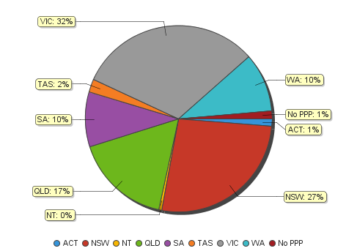
Podiatry practitioners – percentage by principal place of practice

Podiatry practitioners – endorsements by state or territory
Podiatry practitioners | Principal place of practice
Endorsement | ACT | NSW | NT | QLD | SA | TAS | VIC | WA | No PPP | Total
Scheduled Medicines | 1 | 4 |  | 4 | 9 |  | 25 | 27 |  | 70

Podiatry practitioners – specialty by state or territory
Podiatry practitioners | Principal place of practice
Speciality | ACT | NSW | NT | QLD | SA | TAS | VIC | WA | No PPP | Total
Podiatric Surgeon | 1 | 4 |  | 1 | 3 |  | 3 | 16 | 1 | 29

Podiatry practitioners – registration type by age group
Podiatry practitioners | Registration type
Age group | General | General and Specialist | Non-practising | Total
U - 25 | 371 |  | 1 | 372
25 - 29 | 886 | 1 | 18 | 905
30 - 34 | 727 | 2 | 21 | 750
35 - 39 | 569 | 4 | 8 | 581
40 - 44 | 565 | 7 | 13 | 585
45 - 49 | 422 | 5 | 14 | 441
50 - 54 | 329 | 6 | 10 | 345
55 - 59 | 220 | 3 | 4 | 227
60 - 64 | 112 | 1 | 1 | 114
65 - 69 | 34 |  | 4 | 38
70 - 74 | 23 |  |  | 23
75 - 79 | 11 |  |  | 11
80+ | 7 |  |  | 7
Total | 4,276 | 29 | 94 | 4,399

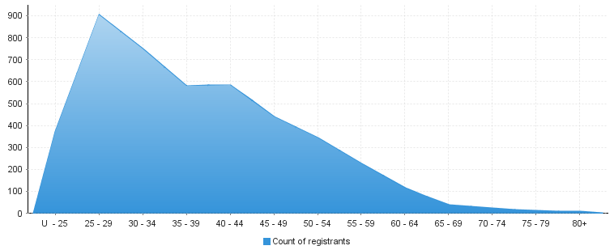
Podiatry practitioners – by age group
Age group | U - 25 | 25 – 29 | 30 - 34 | 35 - 39 | 40 - 44 | 45 - 49 | 50 - 54 | 55 - 59 | 60 - 64 | 65 - 69 | 70 - 74 | 75 - 79 | 80+
Count of registrants | 372 | 905 | 750 | 581 | 585 | 441 | 345 | 227 | 114 | 38 | 23 | 11 | 7

Podiatry practitioners – registration type by gender
Podiatry Practitioners |  | Principal place of practice
Gender | Registration type | ACT | NSW | NT | QLD | SA | TAS | VIC | WA | No PPP | Total
Female | General | 31 | 684 | 12 | 424 | 247 | 63 | 854 | 271 | 29 | 2,615
 | General and Specialist |  | 1 |  |  |  |  |  | 5 |  | 6
 | Non-practising |  | 7 |  | 16 | 7 | 1 | 23 | 4 | 7 | 65
Sub Total |  | 31 | 692 | 12 | 440 | 254 | 64 | 877 | 280 | 36 | 2,686
Male | General | 27 | 467 | 8 | 291 | 158 | 36 | 499 | 156 | 19 | 1,661
 | General and Specialist | 1 | 3 |  | 1 | 3 |  | 3 | 11 | 1 | 23
 | Non-practising |  | 7 |  | 3 | 3 |  | 12 |  | 4 | 29
Sub Total |  | 28 | 477 | 8 | 295 | 164 | 36 | 514 | 167 | 24 | 1,713
Total |  | 59 | 1,169 | 20 | 735 | 418 | 100 | 1,391 | 447 | 60 | 4,399

Podiatry practitioners – percentage by gender
Podiatry Practitioners | Principal place of practice
Gender | ACT | NSW | NT | QLD | SA | TAS | VIC | WA | No PPP | Total
Female | 52.54% | 59.20% | 60.00% | 59.86% | 60.77% | 64.00% | 63.05% | 62.64% | 60.00% | 61.06%
Male | 47.46% | 40.80% | 40.00% | 40.14% | 39.23% | 36.00% | 36.95% | 37.36% | 40.00% | 38.94%

