Podiatry registrant data: December 2014
Published March 2015

Introduction
The role of the Podiatry Board of Australia (the Board) include:
- registering podiatrist and students
- developing standards, codes and guidelines for the podiatry profession
- handling notifications, complaints, investigations and disciplinary hearings
- overseeing the assessment of overseas trained physiotherapists who wish to practise in Australia, and
approving accreditation standards and accredited courses of study.
The Board’s functions are supported by the Australian Health Practitioner Regulation Agency (AHPRA). For information about legislation governing our operations see About AHPRA at http://www.ahpra.gov.au/About-AHPRA/What-We-Do/Legislation.aspx.
The Board has analysed its registration data and produced a number of statistical breakdowns about registrants to share with the profession and community. The Board shares these breakdowns regularly.
For more information on podiatry registration, please see the Board’s website http://www.podiatryboard.gov.au/Registration.aspx

Contents
Podiatry practitioners – registration type by state or territory 3
Podiatry practitioners – percentage by principal place of practice 3
Podiatry practitioners – endorsements by state or territory 4
Podiatry practitioners – specialty by state or territory 4
Podiatry practitioners – registration type by age group 5
Podiatry practitioners – by age group 6
Podiatry practitioners – registration type by gender 7
Podiatry practitioners – percentage by gender 7

Podiatry practitioners – registration type by state or territory
Podiatry practitioner | Principal place of practice
Registration type | ACT | NSW | NT | QLD | SA | TAS | VIC | WA | No PPP | Total
General | 58 | 1,091 | 20 | 718 | 409 | 97 | 1,349 | 434 | 44 | 4,220
General and Specialist | 1 | 5 |  | 1 | 4 |  | 3 | 13 | 1 | 28
Non-practising |  | 13 |  | 17 | 10 | 3 | 40 | 6 | 10 | 99
Total | 59 | 1,109 | 20 | 736 | 423 | 100 | 1,392 | 453 | 55 | 4,347

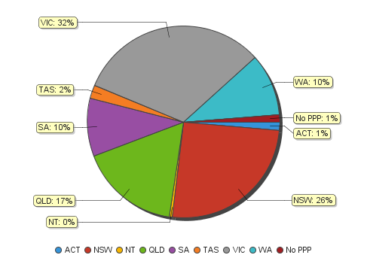
Podiatry practitioners – percentage by principal place of practice

Podiatry practitioners – endorsements by state or territory
Podiatry practitioners | Principal place of practice
Endorsement | ACT | NSW | NT | QLD | SA | TAS | VIC | WA | No PPP | Total
Scheduled Medicines | 1 | 4 | 0 | 3 | 6 | 0 | 24 | 27 | 0 | 65

Podiatry practitioners – specialty by state or territory
Podiatry practitioners | Principal place of practice
Speciality | ACT | NSW | NT | QLD | SA | TAS | VIC | WA | No PPP | Total
Podiatric Surgeon | 1 | 5 |  | 1 | 4 |  | 3 | 13 | 1 | 28

Podiatry practitioners – registration type by age group
Podiatry practitioners | Registration type
Age group | General | General and Specialist | Non-practising | Total
U - 25 | 428 |  |  | 428
25 - 29 | 888 |  | 22 | 910
30 - 34 | 698 |  | 19 | 717
35 - 39 | 544 | 5 | 9 | 558
40 - 44 | 553 | 8 | 13 | 574
45 - 49 | 399 | 4 | 17 | 420
50 - 54 | 339 | 6 | 10 | 355
55 - 59 | 199 | 4 | 2 | 205
60 - 64 | 102 |  | 2 | 104
65 - 69 | 38 |  | 5 | 43
70 - 74 | 18 |  |  | 18
75 - 79 | 8 |  |  | 8
80+ | 6 | 1 |  | 7
Total | 4,220 | 28 | 99 | 4,347

Podiatry practitioners – by age group
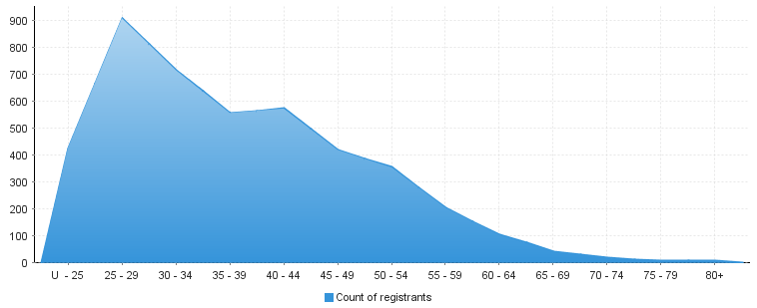
Age group | U - 25 | 25 – 29 | 30 - 34 | 35 - 39 | 40 - 44 | 45 - 49 | 50 - 54 | 55 - 59 | 60 - 64 | 65 - 69 | 70 - 74 | 75 - 79 | 80+
Count of registrants | 428 | 910 | 717 | 558 | 574 | 420 | 355 | 205 | 104 | 43 | 18 | 8 | 7

Podiatry practitioners – registration type by gender
Podiatry Practitioners |  | Principal place pf practice
Gender | Registration type | ACT | NSW | NT | QLD | SA | TAS | VIC | WA | No PPP | Total
Female | General | 32 | 648 | 11 | 427 | 249 | 60 | 855 | 280 | 26 | 2,588
 | General and Specialist |  | 1 |  |  |  |  |  | 4 |  | 5
 | Non-practising |  | 6 |  | 14 | 7 | 3 | 29 | 5 | 5 | 69
Sub Total |  | 32 | 655 | 11 | 441 | 256 | 63 | 884 | 289 | 31 | 2,662
Male | General | 26 | 443 | 9 | 291 | 160 | 37 | 494 | 154 | 18 | 1,632
 | General and Specialist | 1 | 4 |  | 1 | 4 |  | 3 | 9 | 1 | 23
 | Non-practising |  | 7 |  | 3 | 3 |  | 11 | 1 | 5 | 30
Sub Total |  | 27 | 454 | 9 | 295 | 167 | 37 | 508 | 164 | 24 | 1,685
Total |  | 59 | 1,109 | 20 | 736 | 423 | 100 | 1,392 | 453 | 55 | 4,347

Podiatry practitioners – percentage by gender
Podiatry Practitioners | Principal place of practice
Gender | ACT | NSW | NT | QLD | SA | TAS | VIC | WA | No PPP | Total
Female | 54.24% | 59.06% | 55.00% | 59.92% | 60.52% | 63.00% | 63.51% | 63.80% | 56.36% | 61.24%
Male | 45.76% | 40.94% | 45.00% | 40.08% | 39.48% | 37.00% | 36.49% | 36.20% | 43.64% | 38.76%

