Podiatry Board of Australia

Registrant Data

Reporting period: March 2016

Table of contents
Introduction 3
Principal Place of Practice 4
1. Registration Type 4
2. Endorsements 4
3. Specialties 4
Age Group 5
4. Registration Type and Sub type 5
Gender 6
5. Registration Type 6
6. Percentage 6

Introduction
The role of the Podiatry Board of Australia (the Board) includes:
- registering podiatrists, podiatric surgeons and students
- developing standards, codes and guidelines for the podiatry profession
- handling notifications and complaints
- where necessary, conducting panel hearings and referring serious matters to tribunal hearings
- overseeing the assessment of overseas trained practitioners who wish to practise in Australia, and
- approving accreditation standards and accredited courses of study.
The Board’s functions are supported by the Australian Health Practitioner Regulation Agency (AHPRA). For information about legislation governing our operations see About AHPRA at http://www.ahpra.gov.au/About-AHPRA/What-We-Do/Legislation.aspx.
The Board has analysed its registration data and produced a number of statistical breakdowns about registrants to share with the profession and community. The Board shares these breakdowns regularly.
For more information on podiatry registration, please see the Board’s website http://www.podiatryboard.gov.au/Registration.aspx

Principal Place of Practice
- Registration Type
  - Registration type and sub type by principal place of practice
Registration Type | ACT | NSW | NT | QLD | SA | TAS | VIC | WA | No PPP | Total
General | 59 | 1,239 | 20 | 756 | 411 | 103 | 1,441 | 423 | 51 | 4,503
General and Specialist | 1 | 4 |  | 1 | 3 |  | 3 | 17 | 1 | 30
Non-practising | 1 | 13 | 2 | 16 | 11 | 1 | 35 | 3 | 11 | 93
Total | 61 | 1,256 | 22 | 773 | 425 | 104 | 1,479 | 443 | 63 | 4,626

  - Registration type by principal place of practice percentages
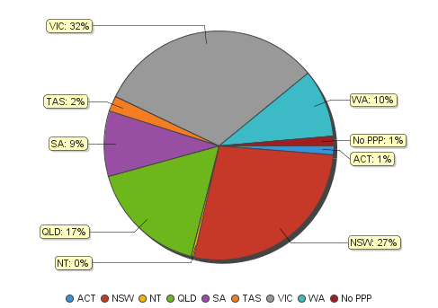

- Endorsements
  - Endorsements
Endorsement | ACT | NSW | NT | QLD | SA | TAS | VIC | WA | No PPP | Total
Scheduled Medicines | 1 | 4 |  | 7 | 9 |  | 24 | 27 |  | 72

- Specialties
  - Specialty
Endorsement | ACT | NSW | NT | QLD | SA | TAS | VIC | WA | No PPP | Total
Podiatric Surgeon | 1 | 4 |  | 1 | 3 |  | 3 | 17 | 1 | 30
Age Group
- Registration Type and Sub type
  - Registration by age group
Age Group | General | General and Specialist | Non-practising | Total
U - 25 | 464 |  | 2 | 466
25 - 29 | 958 | 1 | 16 | 975
30 - 34 | 748 | 2 | 17 | 767
35 - 39 | 582 | 3 | 13 | 598
40 - 44 | 556 | 8 | 12 | 576
45 - 49 | 443 | 6 | 12 | 461
50 - 54 | 341 | 3 | 12 | 356
55 - 59 | 235 | 6 | 3 | 244
60 - 64 | 107 | 1 | 3 | 111
65 - 69 | 38 |  | 2 | 40
70 - 74 | 16 |  | 1 | 17
75 - 79 | 10 |  |  | 10
80+ | 5 |  |  | 5
Total | 4,503 | 30 | 93 | 4,626

  - Registration by age group
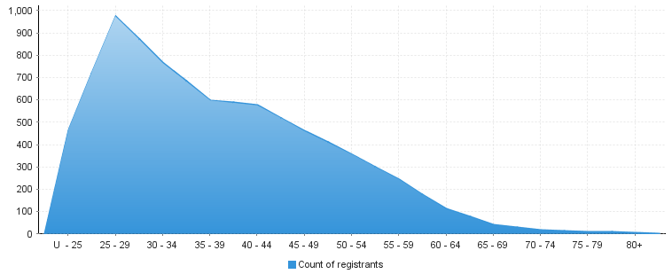

Gender
- Registration Type
  - Gender by state and territory by registration type
Gender | Registration Type | ACT | NSW | NT | QLD | SA | TAS | VIC | WA | No PPP | Total
Female | General | 32 | 718 | 11 | 454 | 250 | 64 | 908 | 266 | 32 | 2,735
 | General and Specialist |  | 1 |  |  |  |  |  | 6 |  | 7
 | Non-practising | 1 | 5 | 2 | 13 | 7 | 1 | 25 | 2 | 7 | 63
Total Female |  | 33 | 724 | 13 | 467 | 257 | 65 | 933 | 274 | 39 | 2,805
Male | General | 27 | 521 | 9 | 302 | 161 | 39 | 533 | 157 | 19 | 1,768
 | General and Specialist | 1 | 3 |  | 1 | 3 |  | 3 | 11 | 1 | 23
 | Non-practising |  | 8 |  | 3 | 4 |  | 10 | 1 | 4 | 30
Total Male |  | 28 | 532 | 9 | 306 | 168 | 39 | 546 | 169 | 24 | 1,821
Total |  | 61 | 1,256 | 22 | 773 | 425 | 104 | 1,479 | 443 | 63 | 4,626

- Percentage
  - Registration by gender percentages
Gender | ACT | NSW | NT | QLD | SA | TAS | VIC | WA | No PPP | Total
Female | 54.10% | 57.64% | 59.09% | 60.41% | 60.47% | 62.50% | 63.08% | 61.85% | 61.90% | 60.64%
Male | 45.90% | 42.36% | 40.91% | 39.59% | 39.53% | 37.50% | 36.92% | 38.15% | 38.10% | 39.36%

