

Podiatry Board of Australia

Registrant data

Reporting period: 1 July 2018 – 30 September 2018

Table of contents
Introduction 3
Principal place of practice 4
1. Registration type 4
2. Endorsements 4
3. Specialties 5
Age group 5
4. Registration type and subtype 5
Gender 6
5. Registration Type 6
6. Percentage 6

Introduction
The role of the Podiatry Board of Australia (the Board) includes:
- registering podiatrists, podiatric surgeons and students
- developing standards, codes and guidelines for the podiatry profession
- handling notifications and complaints
- where necessary, conducting panel hearings and referring serious matters to tribunal hearings
- overseeing the assessment of overseas trained practitioners who wish to practise in Australia, and
- approving accreditation standards and accredited courses of study.
The Board’s functions are supported by the Australian Health Practitioner Regulation Agency (AHPRA). For information about legislation governing our operations see About AHPRA.
The Board has analysed its registration data and produced a number of statistical breakdowns about registrants to share with the profession and community. The Board shares these breakdowns regularly.
For more information on podiatry registration, please see the Board’s website www.podiatryboard.gov.au/

Principal place of practice
- Registration type
  - Registration type and subtype by principal place of practice
Registration Type | ACT | NSW | NT | QLD | SA | TAS | VIC | WA | No PPP | Total
General | 65 | 1,429 | 25 | 862 | 439 | 109 | 1,619 | 434 | 47 | 5,029
General and Specialist | 1 | 4 |  | 2 | 3 |  | 5 | 19 | 1 | 35
Non-practising |  | 20 |  | 20 | 11 | 1 | 33 | 6 | 13 | 104
Total | 66 | 1,453 | 25 | 884 | 453 | 110 | 1,657 | 459 | 61 | 5,168

  - Registration type by principal place of practice percentages

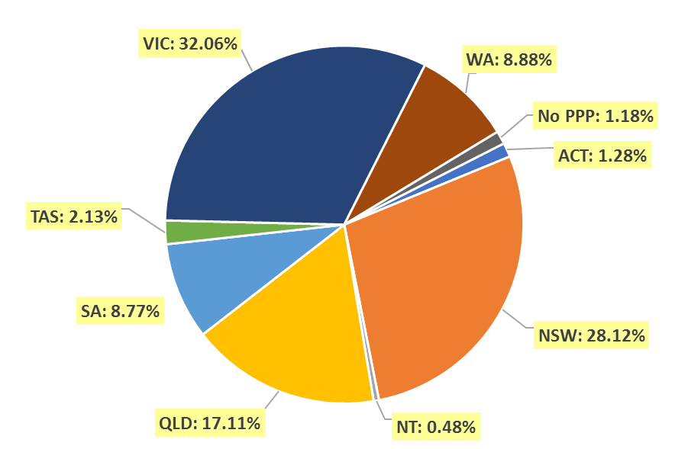

- Endorsements
  - Endorsements
Endorsement | ACT | NSW | NT | QLD | SA | TAS | VIC | WA | No PPP | Total
Scheduled Medicines | 1 | 10 |  | 25 | 9 |  | 28 | 26 |  | 99

- Specialties
  - Specialty
Speciality | ACT | NSW | NT | QLD | SA | TAS | VIC | WA | No PPP | Total
Podiatric Surgeon | 1 | 4 |  | 2 | 3 |  | 5 | 19 | 1 | 35

Age group
- Registration type and subtype
  - Registration by age group
Age group | General | General and Specialist | Non-practising | Total
U - 25 | 366 |  | 1 | 367
25 - 29 | 1,101 | 3 | 17 | 1,121
30 - 34 | 928 | 1 | 23 | 952
35 - 39 | 637 | 3 | 9 | 649
40 - 44 | 581 | 7 | 14 | 602
45 - 49 | 506 | 10 | 13 | 529
50 - 54 | 380 | 5 | 11 | 396
55 - 59 | 302 | 2 | 8 | 312
60 - 64 | 149 | 4 | 5 | 158
65 - 69 | 50 |  | 2 | 52
70 - 74 | 20 |  | 1 | 21
75 - 79 | 5 |  |  | 5
80+ | 4 |  |  | 4
Total | 5,029 | 35 | 104 | 5,168

  - Registration by age group
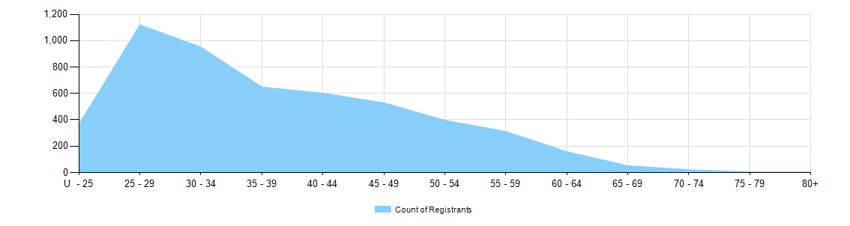
Gender
- Registration Type
  - Gender by state and territory by registration type
Gender | Registration Type | ACT | NSW | NT | QLD | SA | TAS | VIC | WA | No PPP | Total
Female | General | 37 | 797 | 13 | 503 | 267 | 66 | 1,011 | 271 | 25 | 2,990
Female | General and Specialist |  | 1 |  |  |  |  |  | 8 |  | 9
Female | Non-practising |  | 12 |  | 17 | 8 | 1 | 26 | 3 | 9 | 76
Total female |  | 37 | 810 | 13 | 520 | 275 | 67 | 1,037 | 282 | 34 | 3,075
Male | General | 28 | 632 | 12 | 359 | 172 | 43 | 608 | 163 | 22 | 2,039
Male | General and Specialist | 1 | 3 |  | 2 | 3 |  | 5 | 11 | 1 | 26
Male | Non-practising |  | 8 |  | 3 | 3 |  | 7 | 3 | 4 | 28
Total male |  | 29 | 643 | 12 | 364 | 178 | 43 | 620 | 177 | 27 | 2,093
Total |  | 66 | 1,453 | 25 | 884 | 453 | 110 | 1,657 | 459 | 61 | 5,168

- Percentage
  - Registration by gender percentages
Gender | ACT | NSW | NT | QLD | SA | TAS | VIC | WA | No PPP | Total
Female | 56.1% | 55.7% | 52.0% | 58.8% | 60.7% | 60.9% | 62.6% | 61.4% | 55.7% | 59.5%
Male | 43.9% | 44.3% | 48.0% | 41.2% | 39.3% | 39.1% | 37.4% | 38.6% | 44.3% | 40.5%

