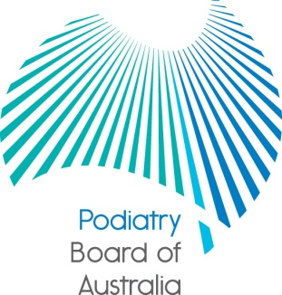

Communiqué
Meeting of the Podiatry Board of Australia held on 27 February 2013
This communiqué highlights key issues from the last meeting of the Podiatry Board of Australia (the Board). At each meeting, the Board considers a wide range of issues, many of which are routine and are not included in this communiqué.
Review of registration standards, codes and guidelines

The Board’s registration standards, guidelines and codes that have been in place since 1 July 2010 are currently being reviewed. The Board, together with the other National Boards will soon be publicly consulting on these reviews and information about the consultations will be published on the Board’s website and communicated in future communiqués.
The consultations will provide an opportunity for practitioners, the public and other stakeholders to provide feedback on these important documents for the profession and the Board encourages practitioners and the community to have their say.
The documents will be released for consultation progressively, with the following consultation documents being released in the coming weeks:
• Guideline for advertising
• podiatry Code of conduct for registered health practitioners
• Mandatory notification guidelines, and
• draft Social media policy.

Other documents, including the Board’s Recency of practice registration standard; Continuing professional development registration standard and guideline; and Endorsement for scheduled medicines registration standard and guideline, will be published for consultation later in the year and you will be notified when they are released.

Stakeholder forum in Adelaide

The Board is hosting a forum for registrants in Adelaide on the evening of Thursday 2 May 2013. This will provide an opportunity for South Australian podiatrists to informally meet members of the Board and discuss issues relating to the registration and regulation of podiatrists under the National Law.

Further details will be provided once the venue has been confirmed and all South Australian podiatrists who have provided their email address to AHPRA will soon be emailed an invitation to the forum. The Board hopes that as many podiatrists as possible will be able to attend.

Panel member recruitment
Under the National Law, the Board convenes health panels and performance and professional standards panels as necessary to hold hearings into specific health, performance or conduct matters about individual registered podiatrists. These panels are made up of members chosen from the list of persons approved by the Board.

The Board has recently concluded a recruitment campaign seeking expressions of interest from experienced podiatrists and community members interested in being included on the Board’s list of approved persons for panel appointments. The Board is pleased with the very positive response it received and applications are now being reviewed. The Board will make a decision in the coming weeks and successful applicants will be notified in due course.
AHPRA consultation on data access and research
AHPRA is seeking feedback on its proposed National Registration and Accreditation Scheme data access and research policy. The policy establishes a consistent approach for data access and research requests across AHPRA and the National Boards. A consultation paper is published on the AHPRA website at http://www.ahpra.gov.au/News/Current-Consultations.aspx. The consultation period ends on 5 April 2013.
Further information
Further information about the Board can be found on the Board’s website at www.podiatryboard.gov.au and practitioners are encouraged to refer to the site for news and updates on Policy and Guidelines affecting their profession.

Cathy Loughry
Chair
Podiatry Board of Australia
21 March 2013

