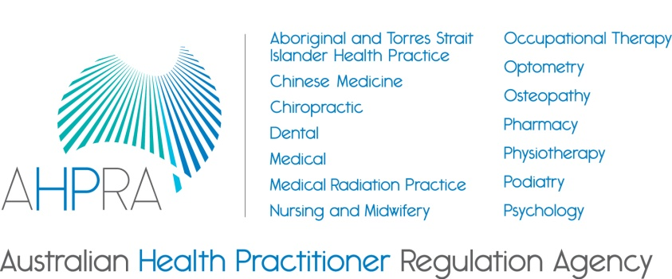

For registered health practitioners

Guidelines for mandatory notifications

March 2014

About the National Boards and AHPRA
The 14 National Boards regulating registered health practitioners in Australia are responsible for
registering practitioners and students (except for in psychology, which has provisional psychologists),
setting the standards that practitioners must meet, and managing notifications (complaints) about the
health, conduct or performance of practitioners.

The Australian Health Practitioner Regulation Agency (AHPRA) works in partnership with the National
Boards to implement the National Registration and Accreditation Scheme, under the Health Practitioner Regulation National Law, as in force in each state and territory (the National Law).

The core role of the National Boards and AHPRA is to protect the public.
About these guidelines
These guidelines have been developed jointly by the National Boards under section 39 of the National Law. The guidelines are developed to provide direction to registered health practitioners, employers of practitioners and education providers about the requirements for mandatory notifications under the National Law.
The inclusion of mandatory notification requirements in the National Law is an important policy initiative for public protection.
The relevant sections of the National Law are attached.
Who needs to use these guidelines?
These guidelines are relevant to:
- health practitioners registered under the National Law
- employers of practitioners, and
- education providers.
Students who are registered in a health profession under the National Law should be familiar with these guidelines. Although the National Law does not require a student to make a mandatory notification, a notification can be made about an impaired student.

Contents
Summary 4
1. Introduction 4
1.1 Voluntary notifications 4
1.2 Protection for people making a notification 5
2. General obligations 5
2.1 What is a reasonable belief? 5
2.2 What is 'the public'? 6
3. Notifiable conduct 6
3.1 Practise while intoxicated by alcohol or drugs (section 140(a)) 6
3.2 Sexual misconduct in connection with the practice of the practitioner’s profession (section 140(b)) 7
3.3 Placing the public at risk of substantial harm because of an impairment (section 140(c)) 8
3.4 Placing the public at risk of harm because of practice in a way that constitutes a significant departure from accepted professional standards (section 140(d)) 9
4. Exceptions to the requirement of practitioners to make a mandatory notification 10
5. Mandatory notifications about impaired students 11
6. Consequences of failure to notify 12
6.1 Registered health practitioners 12
6.2 Employers of health practitioners 12
7. How a notification is made (section 146) 12
Review 13
Appendix A: Extract of relevant provisions from the National Law 14

Summary
These guidelines explain the requirements for registered health practitioners, employers of practitioners and education providers to make mandatory notifications under the National Law to prevent the public being placed at risk of harm.
The threshold to be met to trigger a mandatory notification in relation to a practitioner is high. The practitioner or employer must have first formed a reasonable belief that the behaviour constitutes notifiable conduct or a notifiable impairment or, in the case of an education provider, a notifiable impairment (see Section 3 for the definition of ‘notifiable conduct’ and Appendix A for the definition of ‘impairment’).
Making a mandatory notification is a serious step to prevent the public from being placed at risk of harm and should only be taken on sufficient grounds. The guidelines explain when these grounds are likely to arise.
Importantly, the obligation to make a mandatory notification applies to the conduct or impairment of all practitioners, not just those within the practitioner’s own health profession.
These guidelines also address the role of the Australian Health Practitioner Regulation Agency (AHPRA) as the body for receiving notifications and referring them to the relevant National Board.
- Introduction
The National Law requires practitioners, employers and education providers to report ‘notifiable conduct’, as defined in section 140 of the National Law, to AHPRA in order to prevent the public being placed at risk of harm.
These guidelines explain how the Boards will interpret these mandatory notification requirements. They will help practitioners, employers and education providers understand how to work with these requirements – that is, whether they must make a notification about a practitioner’s conduct and when.
The threshold to be met to trigger the requirement to report notifiable conduct in relation to a practitioner is high and the practitioner or employer must have first formed a reasonable belief that the behaviour constitutes notifiable conduct.
The aim of the mandatory notification requirements is to prevent the public from being placed at risk of harm. The intention is that practitioners notify AHPRA if they believe that another practitioner has behaved in a way which presents a serious risk to the public. The requirements focus on serious instances of substandard practice or conduct by practitioners, or serious cases of impairment, that could place members of the public at risk. For students, the requirements focus on serious cases of impairment of students.
That is, the requirements focus on behaviour that puts the public at risk of harm, rather than not liking the way someone else does something or feeling that they could do their job better.
Similarly, if the only risk is to the practitioner alone, and there is no risk to the public, the threshold for making a mandatory notification would not be reached. For example, in a case where the risk is clearly addressed by being appropriately managed through treatment and the practitioner is known to be fully compliant with that, mandatory notification would not be required. Conversely, a mandatory notification is required if the risk to the public is not mitigated by treatment of the practitioner or in some other way.
  - Voluntary notifications
The National Law also provides for voluntary notifications for behaviour that presents a risk but does not meet the threshold for notifiable conduct or for notifications made by individuals who are not subject to the mandatory notification obligations such as patients or clients (see ss. 144 and 145 of the National Law).

  - Protection for people making a notification
The National Law protects practitioners, employers and education providers who make notifications in good faith under the National Law. ‘Good faith’ is not defined in the National Law so has its ordinary meaning of being well-intentioned or without malice. Section 237 provides protection from civil, criminal and administrative liability, including defamation, for people making notifications in good faith. The National Law clarifies that making a notification is not a breach of professional etiquette or ethics or a departure from accepted standards of professional conduct. These provisions protect practitioners making mandatory notifications from legal liability and reinforce that making mandatory notifications under the National Law is consistent with professional conduct and a practitioner’s ethical responsibilities. Legally mandated notification requirements override privacy laws. Practitioners should be aware that if they make notifications that are frivolous, vexatious or not in good faith, they may be subject to conduct action.
- General obligations
The obligation is on any practitioner or employer who forms a reasonable belief that another practitioner has engaged in notifiable conduct to make a report to AHPRA as soon as practicable. The definition of ‘notifiable conduct’ is set out in section 140 of the National Law (also refer to Section 3 of these guidelines for more information on notifiable conduct). In this context, the word ‘practicable’ has its ordinary meaning of ‘feasible’ or ’possible’.
The mandatory notification obligation applies to all practitioners and employers of practitioners in relation to the notifiable conduct of practitioners. The obligation applies to practitioners in all registered health professions, not just those in the same health profession as the practitioner. It also applies where the notifying practitioner is also the treating practitioner for a practitioner, except in Western Australia and Queensland in certain circumstances (see Section 4 Exceptions to the requirement of practitioners to make a mandatory notification of these guidelines for details).
There is also a mandatory obligation for education providers and practitioners to report a student with an impairment that may place the public at substantial risk of harm.
While the mandatory reporting provisions in the National Law are an important policy change, the duties covered in them are consistent with general ethical practice and professional obligations. In addition to their legal obligations with respect to mandatory reporting, practitioners are also under an ethical obligation to notify concerns about a practitioner, in accordance with the broad ethical framework set out in the health profession’s code of conduct (see the Code of conduct and the voluntary reporting provisions of the National Law). More information about making a voluntary notification is published on the National Boards’ and AHPRA’s websites.
There are some exceptions to the requirement for practitioners to notify AHPRA of notifiable conduct, which are discussed at Section 4 Exceptions to the requirement of practitioners to make a mandatory notification.
These guidelines do not affect other mandatory reporting requirements that may be established in separate legislation, for example requirements to report child abuse.
  - What is a reasonable belief?
For practitioners reporting notifiable conduct, a ‘reasonable belief’ must be formed in the course of practising the profession. The following principles are drawn from legal cases which have considered the meaning of reasonable belief.
- A belief is a state of mind.
- A reasonable belief is a belief based on reasonable grounds.
- A belief is based on reasonable grounds when:
- all known considerations relevant to the formation of a belief are taken into account including matters of opinion, and
- those known considerations are objectively assessed.
A just and fair judgement that reasonable grounds exist in support of a belief can be made when all known considerations are taken into account and objectively assessed.
A reasonable belief requires a stronger level of knowledge than a mere suspicion. Generally it would involve direct knowledge or observation of the behaviour which gives rise to the notification, or, in the case of an employer, it could also involve a report from a reliable source or sources. Mere speculation, rumours, gossip or innuendo are not enough to form a reasonable belief.
A reasonable belief has an objective element – that there are facts which could cause the belief in a reasonable person; and a subjective element – that the person making the notification actually has that belief.
A notification should be based on personal knowledge of facts or circumstances that are reasonably trustworthy and that would justify a person of average caution, acting in good faith, to believe that notifiable conduct has occurred or that a notifiable impairment exists. Conclusive proof is not needed. The professional background, experience and expertise of a practitioner, employer or education provider will also be relevant in forming a reasonable belief.
The most likely example of where a practitioner or employer would form a reasonable belief is where the person directly observes notifiable conduct, or, in relation to an education provider, observes the behaviour of an impaired student. When a practitioner is told about notifiable conduct that another practitioner or patient has directly experienced or observed, the person with most direct knowledge about the notifiable conduct should generally be encouraged to make a notification themselves.
  - What is ‘the public’?
Several of the mandatory notification provisions refer to ‘the public being placed at risk of harm’. In the context of notifications, ‘the public’ can be interpreted as persons that access the practitioner’s regulated health services or the wider community which could potentially have been placed at risk of harm by the practitioner’s services.
- Notifiable conduct
Section 140 of the National Law defines ‘notifiable conduct’ as when a practitioner has:
(a) practised the practitioner’s profession while intoxicated by alcohol or drugs; or
(b) engaged in sexual misconduct in connection with the practice of the practitioner’s profession; or
(c) placed the public at risk of substantial harm in the practitioner’s practice of the profession because the practitioner has an impairment; or
(d) placed the public at risk of harm because the practitioner has practised the profession in a way that constitutes a significant departure from accepted professional standards.
The following sections of the guidelines discuss these types of notifiable conduct, followed by the exceptions. The guidelines are only examples of decision-making processes, so practitioners, employers and education providers should check the exceptions to make sure they do not apply.
If a practitioner engages in more than one type of notifiable conduct, each type is required to be notified.
  - Practise while intoxicated by alcohol or drugs (section 140(a))
The requirement to make a mandatory notification is triggered by a practitioner practising their profession while intoxicated by alcohol or drugs. The word ‘intoxicated’ is not defined in the National Law, so the word has its ordinary meaning of ‘under the influence of alcohol or drugs’.
The Boards will consider a practitioner to be intoxicated where their capacity to exercise reasonable care and skill in the practice of the health profession is impaired or adversely affected as a result of being under the influence of drugs or alcohol. The key issue is that the practitioner has practised while intoxicated, regardless of the time that the drugs or alcohol were consumed.
The National Law does not require mandatory notification of a practitioner who is intoxicated when they are not practising their health profession (that is, in their private life), unless the intoxication triggers another ground for mandatory notification.

Decision guide – notifying intoxication
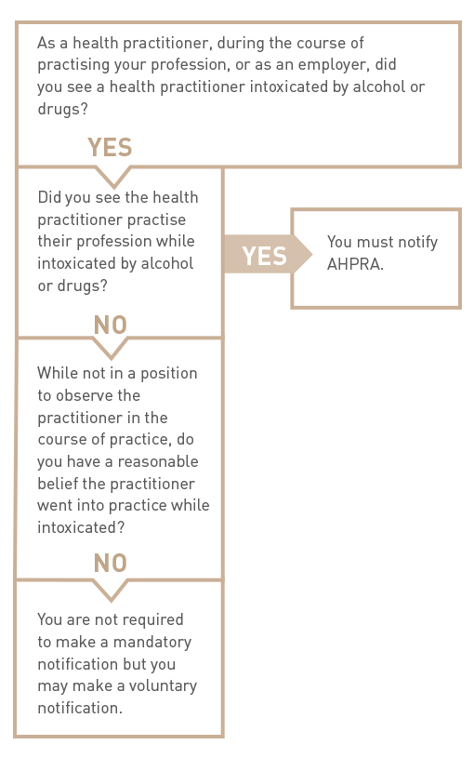
  - Sexual misconduct in connection with the practice of the practitioner’s profession (section 140(b))
Section 140(b) relates to sexual misconduct in connection with the practice of the practitioner’s health profession; that is, in relation to persons under the practitioner’s care or linked to the practitioner’s practice of their health profession.
Engaging in sexual activity with a current patient or client will constitute sexual misconduct in connection with the practice of the practitioner’s health profession, regardless of whether the patient or client consented to the activity or not. This is because of the power imbalance between practitioners and their patients or clients.
Sexual misconduct also includes making sexual remarks, touching patients or clients in a sexual way, or engaging in sexual behaviour in front of a patient or client. Engaging in sexual activity with a person who is closely related to a patient or client under the practitioner’s care may also constitute misconduct. In some cases, someone who is closely related to a patient or client may also be considered a patient or client; for example, the parent of a child patient or client.
Engaging in sexual activity with a person formerly under a practitioner’s care (i.e. after the termination of the practitioner–patient/client relationship) may also constitute sexual misconduct. Relevant factors will include the cultural context, the vulnerability of the patient or client due to issues such as age, capacity and/or health conditions; the extent of the professional relationship; for example, a one-off treatment in an emergency department compared to a long-term program of treatment; and the length of time since the practitioner–patient/client relationship ceased.
Decision guide – notifying sexual misconduct
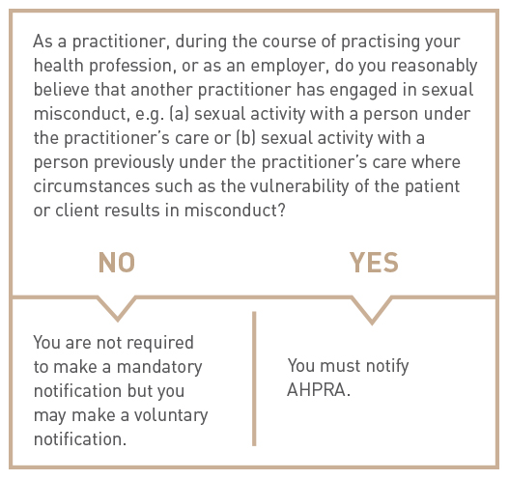
  - Placing the public at risk of substantial harm because of an impairment (section 140(c))
Section 5 of the National Law defines ‘impairment’ for a practitioner or an applicant for registration in a health profession as meaning a person has ‘a physical or mental impairment, disability, condition or disorder (including substance abuse or dependence) that detrimentally affects or is likely to detrimentally affect the person’s capacity to practise the profession.’
To trigger this notification, a practitioner must have placed the public at risk of substantial harm. ‘Substantial harm’ has its ordinary meaning; that is, considerable harm such as a failure to correctly or appropriately diagnose or treat because of the impairment. For example, a practitioner who has an illness which causes cognitive impairment so they cannot practise effectively would require a mandatory notification. However, a practitioner who has a blood-borne virus who practises appropriately and safely in light of their condition and complies with any registration standards or guidelines and professional standards and protocols would not trigger a notification.
The context of the practitioner’s work is also relevant. If registered health practitioners, employers and education providers are aware that the employer knows of the practitioner’s impairment, and has put safeguards in place such as monitoring and supervision, this may reduce or prevent the risk of substantial harm.

Decision guide – notifying impairment in relation to a practitioner
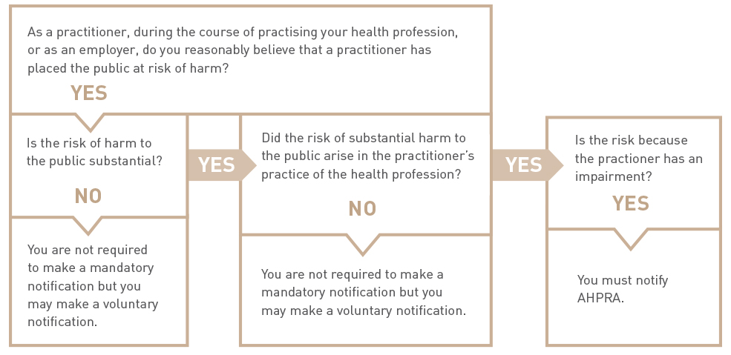
* for notification of student impairment, please see Section 5 of these guidelines
  - Placing the public at risk of harm because of practice that constitutes a significant departure from accepted professional standards (section 140(d))
The term ‘accepted professional standards’ requires knowledge of the professional standards that are accepted within the health profession and a judgement about whether there has been a significant departure from them. This judgement may be easier for other members of the practitioner’s health profession.
Mandatory notifications about a practitioner from another health profession are most likely to arise in a team environment where different health professions are working closely together and have a good understanding of the contribution of each practitioner; for example, a surgical or mental health team.
The difference from accepted professional standards must be significant. The term ‘significant’ means important, or of consequence (Macquarie concise dictionary). Professional standards cover not only clinical skills but also other standards of professional behaviour. A significant departure is one which is serious and would be obvious to any reasonable practitioner.
The notifiable conduct of the practitioner must place the public at risk of harm as well as being a significant departure from accepted professional standards before a notification is required. However, the risk of harm just needs to be present – it does not need to be a substantial risk, as long as the practitioner’s practice involves a significant departure from accepted professional standards. For example, a clear breach of the health profession’s code of conduct which places the public at risk of harm would be enough.
This provision is not meant to trigger notifications based on different professional standards within a health profession, provided the standards are accepted within the health profession; that is, by a reasonable proportion of practitioners. For example, if one practitioner uses a different standard to another practitioner, but both are accepted standards within the particular health profession, this would not qualify as a case of notifiable conduct. Similarly, if a practitioner is engaged in innovative practice but within accepted professional standards, it would not trigger the requirement to report.

Decision guide – significant departure from accepted professional standards
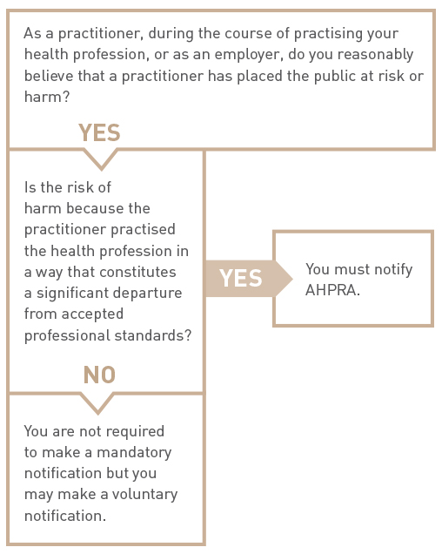
- Exceptions to the requirement of practitioners to make a mandatory notification
There are particular exceptions to the requirement to make a mandatory notification for practitioners. The exceptions relate to the circumstances in which the practitioner forms the reasonable belief in misconduct or impairment. They arise where the practitioner who would be required to make the notification:
- is employed or engaged by a professional indemnity insurer, and forms the belief because of a disclosure in the course of a legal proceeding or the provision of legal advice arising from the insurance policy
- forms the belief while providing advice about legal proceedings or the preparation of legal advice
- is exercising functions as a member of a quality assurance committee, council or other similar body approved or authorised under legislation which prohibits the disclosure of the information
- reasonably believes that someone else has already made a notification,
- is a treating practitioner, practising in Western Australia, or
- is a treating practitioner, practising in Queensland in certain circumstances.
Practitioners in Western Australia are not required to make a mandatory notification when their reasonable belief about misconduct or impairment is formed in the course of providing health services to a health practitioner or student. However, practitioners in Western Australia continue to have a professional and ethical obligation to protect and promote public health and safety. They may therefore make a voluntary notification or may encourage the practitioner or student they are treating to self-report.
From the commencement of the Health Ombudsman Act 2013, practitioners in Queensland are not required to make a mandatory notification when their reasonable belief is formed as a result of providing a health service to a health practitioner, where the practitioner providing the service reasonably believes that the notifiable conduct relates to an impairment which will not place the public at substantial risk of harm and is not professional misconduct. Once the Act is in force in Queensland, mandatory notifications must be made to the Health Ombudsman, rather than AHPRA. The Ombudsman must advise AHPRA about the notification in certain circumstances.
Practitioners should refer to Appendix A of these guidelines for an extract of the relevant legislation; see section 141 if it is possible one of these exceptions might apply.
- Mandatory notifications about impaired students
Education providers are also required, under section 143 of the National Law, to make mandatory notifications in relation to students, if the provider reasonably believes:
- ‘a student enrolled with the provider has an impairment that, in the course of the student undertaking clinical training, may place the public at substantial risk of harm, or
- a student for whom the provider has arranged clinical training has an impairment that, in the course of the student undertaking the clinical training, may place the public at substantial risk of harm.’
Practitioners are required to make a mandatory notification in relation to a student if the practitioner reasonably believes that a student has an impairment that, in the course of the student undertaking clinical training, may place the public at substantial risk of harm (section141(1)(b)).
In all cases, the student’s impairment must place the public at substantial, or considerable, risk of harm in the course of clinical training.
In relation to a student, ‘impairment’ is defined under section 5 of the National Law to mean the student ‘has a physical or mental impairment, disability, condition or disorder (including substance abuse or dependence) that detrimentally affects or is likely to detrimentally affect the student’s capacity to undertake clinical training —
(i) as part of the approved program of study in which the student is enrolled; or
(ii) arranged by an education provider.’
An education provider who does not notify the National Agency as required by section 143 does not commit an offence. However, the National Board that registered the student must publish details of the failure to notify on the Board’s website and AHPRA may, on the recommendation of the National Board, include a statement about the failure in AHPRA’s annual report.

Decision guide – student impairment
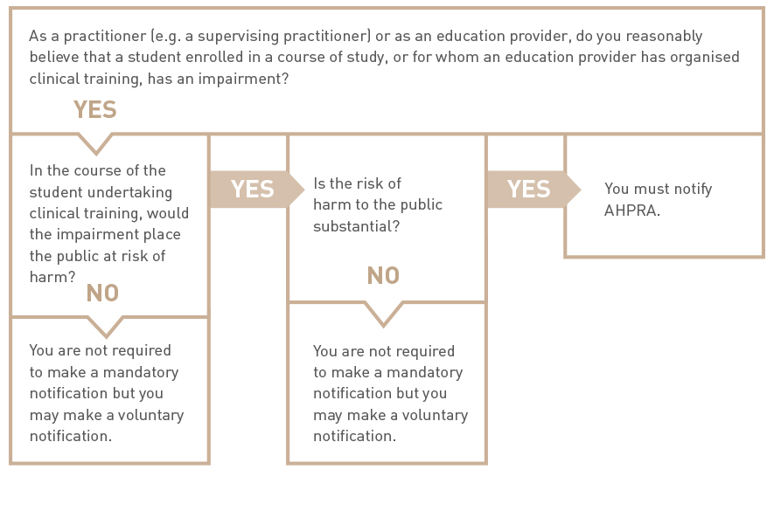
- Consequences of failure to notify
  - Registered health practitioners
Although there are no penalties prescribed under the National Law for a practitioner who fails to make a mandatory notification, any practitioner who fails to make a mandatory notification when required may be subject to health, conduct or performance action.
  - Employers of health practitioners
There are also consequences for an employer who fails to notify AHPRA of notifiable conduct as required by section 142 of the National Law.
If AHPRA becomes aware of such a failure, it must give a written report about the failure to the responsible Minister for the jurisdiction in which the notifiable conduct occurred. As soon as practicable after receiving such a report, the responsible Minister must report the employer’s failure to notify to a health complaints entity, the employer’s licensing authority or another appropriate entity in that participating jurisdiction.
Importantly, the requirement to make a mandatory notification does not reduce an employer’s responsibility to manage the practitioner employee’s performance and protect the public from being placed at risk of harm. However, if an employer has a reasonable belief that a practitioner has behaved in a way that constitutes notifiable conduct, then the employer must notify, regardless of whether steps are put in place to prevent recurrence of the conduct or impairment, or whether the practitioner subsequently leaves the employment.
- How a notification is made (section 146)
Under the National Law, notifications are be made to AHPRA, which receives notifications and refers them to the relevant National Board. The notification must include the basis for making the notification; that is, practitioners, employers and education providers must say what the notification is about. It may assist practitioners, employers and education providers in making a notification if they have documented the reasons for the notification, including the date and time that they noticed the conduct or impairment.
To make a notification verbally, practitioners, employers and education providers may ring 1300 419 495 or go to any of the state and territory AHPRA offices.
To make a notification in writing, go to the Notifications and outcomes section of the AHPRA website at www.ahpra.gov.au, download a notification form and post your completed form to AHPRA, GPO Box 9958 in your capital city.
If you are unsure about whether to make a mandatory notification, you may wish to seek advice from your insurer and/or professional association.
Review
Date of issue: 17 March 2014
Date of review: These guidelines will be reviewed from time to time as required. This will generally be at least every three years.
Last reviewed: September 2013

Appendix A: Extract of relevant provisions from the National Law
s. 5 impairment, in relation to a person, means the person has a physical or mental impairment, disability, condition or disorder (including substance abuse or dependence) that detrimentally affects or is likely to detrimentally affect—
(a) for a registered health practitioner or an applicant for registration in a health profession, the person’s capacity to practise the profession; or
(b) for a student, the student’s capacity to undertake clinical training—
(i) as part of the approved program of study in which the student is enrolled; or
(ii) arranged by an education provider.
Part 5, Division 3 Registration standards and codes and guidelines
39 Codes and guidelines
A National Board may develop and approve codes and guidelines—
(a) to provide guidance to the health practitioners it registers; and
(b) about other matters relevant to the exercise of its functions.
Example. A National Board may develop guidelines about the advertising of regulated health services by health practitioners registered by the Board or other persons for the purposes of section 133.
40 Consultation about registration standards, codes and guidelines
(1) If a National Board develops a registration standard or a code or guideline, it must ensure there is wide-ranging consultation about its content.
(2) A contravention of subsection (1) does not invalidate a registration standard, code or guideline.
(3) The following must be published on a National Board’s website—
(a) a registration standard developed by the Board and approved by the Ministerial Council;
(b) a code or guideline approved by the National Board.
(4) An approved registration standard or a code or guideline takes effect—
(a) on the day it is published on the National Board’s website; or
(b) if a later day is stated in the registration standard, code or guideline, on that day.
41 Use of registration standards, codes or guidelines in disciplinary proceedings
An approved registration standard for a health profession, or a code or guideline approved by a National Board, is admissible in proceedings under this Law or a law of a co-regulatory jurisdiction against a health practitioner registered by the Board as evidence of what constitutes appropriate professional conduct or practice for the health profession.
Part 8, Division 2 Mandatory notifications
140 Definition of notifiable conduct
In this Division—
notifiable conduct, in relation to a registered health practitioner, means the practitioner has—
(a) practised the practitioner’s profession while intoxicated by alcohol or drugs; or
(b) engaged in sexual misconduct in connection with the practice of the practitioner’s profession; or
(c) placed the public at risk of substantial harm in the practitioner’s practice of the profession because the practitioner has an impairment; or
(d) placed the public at risk of harm because the practitioner has practised the profession in a way that constitutes a significant departure from accepted professional standards.
Education provider means—
(a) a university; or
(b) a tertiary education institution, or another institution or organisation, that provides vocational training; or
(c) a specialist medical college or other health profession college.
141 Mandatory notifications by health practitioners
(1) This section applies to a registered health practitioner (the first health practitioner) who, in the course of practising the first health practitioner’s profession, forms a reasonable belief that—
(a) another registered health practitioner (the second health practitioner) has behaved in a way that constitutes notifiable conduct; or
(b) a student has an impairment that, in the course of the student undertaking clinical training, may place the public at substantial risk of harm.
(2) The first health practitioner must, as soon as practicable after forming the reasonable belief, notify the National Agency of the second health practitioner’s notifiable conduct or the student’s impairment.
Note. See section 237 which provides protection from civil, criminal and administrative liability for persons who, in good faith, make a notification under this Law. Section 237(3) provides that the making of a notification does not constitute a breach of professional etiquette or ethics or a departure from accepted standards of professional conduct and nor is any liability for defamation incurred.
(3) A contravention of subsection (2) by a registered health practitioner does not constitute an offence but may constitute behaviour for which action may be taken under this Part.
(4) For the purposes of subsection (1), the first health practitioner does not form the reasonable belief in the course of practising the profession if—
(a) the first health practitioner—
(i) is employed or otherwise engaged by an insurer that provides professional indemnity insurance that relates to the second health practitioner or student; and
(ii) forms the reasonable belief the second health practitioner has behaved in a way that constitutes notifiable conduct, or the student has an impairment, as a result of a disclosure made by a person to the first health practitioner in the course of a legal proceeding or the provision of legal advice arising from the insurance policy; or
(b) the first health practitioner forms the reasonable belief in the course of providing advice in relation to the notifiable conduct or impairment for the purposes of a legal proceeding or the preparation of legal advice; or
(c) the first health practitioner is a legal practitioner and forms the reasonable belief in the course of providing legal services to the second health practitioner or student in relation to a legal proceeding or the preparation of legal advice in which the notifiable conduct or impairment is an issue; or
Application of the National Law in Western Australia
Part 2, Section 4(7) Health Practitioner Regulation National Law (WA) Act 2010
In this Schedule after section 141(4)(c) insert—
141(4)(d) the first health practitioner forms the reasonable belief in the course of providing health services to the second health practitioner or student; or

Application of the National Law in Queensland
section 25 Health Ombudsman Act 2013 (3) National Law provisions, section 141— insert—
(5) Subsection (2) does not apply in relation to the second health practitioner’s notifiable

conduct if the first health practitioner—
(a) forms the reasonable belief as a result of providing a health service to the second health practitioner; and
(b) reasonably believes that the notifiable conduct—
(i) relates to an impairment which will not place the public at substantial risk of harm; and
(ii) is not professional misconduct

(d) the first health practitioner—
(i) forms the reasonable belief in the course of exercising functions as a member of a quality assurance committee, council or other body approved or authorised under an Act of a participating jurisdiction; and
(ii) is unable to disclose the information that forms the basis of the reasonable belief because a provision of that Act prohibits the disclosure of the information; or
(e) the first health practitioner knows, or reasonably believes, the National Agency has been notified of the notifiable conduct or impairment that forms the basis of the reasonable belief.
142 Mandatory notifications by employers
(1) If an employer of a registered health practitioner reasonably believes the health practitioner has behaved in a way that constitutes notifiable conduct, the employer must notify the National Agency of the notifiable conduct.
Note. See section 237 which provides protection from civil, criminal and administrative liability for persons who, in good faith, make a notification under this Law. Section 237(3) provides that the making of a notification does not constitute a breach of professional etiquette or ethics or a departure from accepted standards of professional conduct and nor is any liability for defamation incurred.
(2) If the National Agency becomes aware that an employer of a registered health practitioner has failed to notify the Agency of notifiable conduct as required by subsection (1), the Agency must give a written report about the failure to the responsible Minister for the participating jurisdiction in which the notifiable conduct occurred.
(3) As soon as practicable after receiving a report under subsection (2), the responsible Minister must report the employer’s failure to notify the Agency of the notifiable conduct to a health complaints entity, the employer’s licensing authority or another appropriate entity in that participating jurisdiction.
(4) In this section—
employer, of a registered health practitioner, means an entity that employs the health practitioner under a contract of employment or a contract for services.
licensing authority, of an employer, means an entity that under a law of a participating jurisdiction is responsible for licensing, registering or authorising the employer to conduct the employer’s business.
143 Mandatory notifications by education providers
(1) An education provider must notify the National Agency if the provider reasonably believes—
(a) a student enrolled in a program of study provided by the provider has an impairment that, in the course of the student undertaking clinical training as part of the program of study, may place the public at substantial risk of harm; or
(b) a student for whom the education provider has arranged clinical training has an impairment that, in the course of the student undertaking the clinical training, may place the public at substantial risk of harm;
Note. See section 237 which provides protection from civil, criminal and administrative liability for persons who make a notification under this Law. Section 237(3) provides that the making of a notification does not constitute a breach of professional etiquette or ethics or a departure from accepted standards of professional conduct and nor is any liability for defamation incurred.
(2) A contravention of subsection (1) does not constitute an offence.
144 Grounds for voluntary notification
(1) A voluntary notification about a registered health practitioner may be made to the National Agency on any of the following grounds—
(a) that the practitioner’s professional conduct is, or may be, of a lesser standard than that which might reasonably be expected of the practitioner by the public or the practitioner’s professional peers;
(b) that the knowledge, skill or judgment possessed, or care exercised by, the practitioner in the practice of the practitioner’s health profession is, or may be, below the standard reasonably expected;
(c) that the practitioner is not, or may not be, a suitable person to hold registration in the health profession, including, for example, that the practitioner is not a fit and proper person to be registered in the profession;
(d) that the practitioner has, or may have, an impairment;
(e) that the practitioner has, or may have, contravened this Law;
(f) that the practitioner has, or may have, contravened a condition of the practitioner’s registration or an undertaking given by the practitioner to a National Board;
(g) that the practitioner’s registration was, or may have been, improperly obtained because the practitioner or someone else gave the National Board information or a document that was false or misleading in a material particular.
(2) A voluntary notification about a student may be made to the National Agency on the grounds that—
(a) the student has been charged with an offence, or has been convicted or found guilty of an offence, that is punishable by 12 months imprisonment or more; or
(b) the student has, or may have, an impairment; or
(c) that the student has, or may have, contravened a condition of the student’s registration or an undertaking given by the student to a National Board.
145 Who may make voluntary notification
Any entity that believes that a ground on which a voluntary notification may be made exists in relation to a registered health practitioner or a student may notify the National Agency.
Note. See section 237 which provides protection from civil, criminal and administrative liability for persons who, in good faith, make a notification under this Law.
Part 8, Division 4 Making a notification
146 How notification is made
(1) A notification may be made to the National Agency—
(a) verbally, including by telephone; or
(b) in writing, including by email or other electronic means.
(2) A notification must include particulars of the basis on which it is made.
(3) If a notification is made verbally, the National Agency must make a record of the notification.
Part 11, Division 1, section 237 Protection from liability for persons making notification or otherwise providing information
(1) This section applies to a person who, in good faith—
(a) makes a notification under this Law; or
(b) gives information in the course of an investigation or for another purpose under this Law to a person exercising functions under this Law.
(2) The person is not liable, civilly, criminally or under an administrative process, for giving the information.
(3) Without limiting subsection (2)—
(a) the making of the notification or giving of the information does not constitute a breach of professional etiquette or ethics or a departure from accepted standards of professional conduct; and
(b) no liability for defamation is incurred by the person because of the making of the notification or giving of the information.
(4) The protection given to the person by this section extends to—
(a) a person who, in good faith, provided the person with any information on the basis of which the notification was made or the information was given; and
(b) a person who, in good faith, was otherwise concerned in the making of the notification or giving of the information.
Application of the National Law in Queensland
section 25 Health Ombudsman Act 2013
(1) National Law provisions, section 141(2) and (4(e), ‘National Agency’—
omit, insert—
health ombudsman
(2) National Law provisions, section 141(3), after ‘this Part’—
insert—
or the Health Ombudsman Act 2013
(3) National Law provisions, section 141—insert—
(5) Subsection (2) does not apply in relation to the second health practitioner’s notifiable conduct if the first health practitioner—
(a) forms the reasonable belief as a result of providing a health service to the second health practitioner; and
(b) reasonably believes that the notifiable conduct—
(i) relates to an impairment which will not place the public at substantial risk of harm; and
(ii) is not professional misconduct
26 Amendment of s 142 (Mandatory notifications by employers)

(1) National Law provisions, section 142(1), ‘National Agency’—
omit, insert—
health ombudsman

(2) National Law provisions, section 142(2) and (3)—
omit, insert—
(2) If the health ombudsman becomes aware that an employer of a registered health practitioner has failed to notify the health ombudsman of notifiable conduct as required by subsection (1), the health ombudsman—
(a) must notify the National Agency; and
(b) may—
(i) refer the matter to the employer’s licensing authority; or
(ii) refer the matter to another appropriate entity in this jurisdiction or another jurisdiction; or
(iii) advise the responsible Minister of the matter.
(3) National Law provisions, section 142(4)—
renumber as section 142(3).
27 Amendment of s 143 (Mandatory notifications by education providers)
(1) National Law provisions, section 143(1),
‘National Agency’—
omit, insert—
health ombudsman
(2) National Law provisions, section 143(2) and (3)—
renumber as section 143(3) and (4).
(3) National Law provisions, section 143—
insert—
(2) The health ombudsman must give to the National Agency a copy of each notification received under subsection (1).

These changes are made in the Health Ombudsman Act 2013 (Qld), which was assented to on 29 August 2013 and will commence on a day to be fixed by proclamation. These mandatory notifications guidelines will be updated to reflect the commencement.

